**SD2990 – Co Huynh Huu**

*Source code GitHub link: https://github.com/hhuuco26/KPI2019.git*

**1. KPI tartget result overview**:

- Front end: using Angular 6+ | **OK**

- Identity server 4 authentication | **OK**

- Back end: ASP.net core API, gRPC. | **50%,** *implement gRPC not successfully*

- Deploy them to 3 or more dockers. | *0%, still learning how to deploy Docker*

- Apply message queue | *0%, researched, not implemented yet*

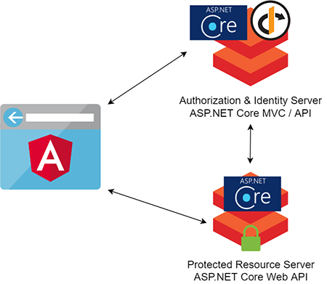

**2. Development Environment**

- Visual Studio 2019

- Visual Studio Code

- .NET Core SDK 2.2.104

- Angular 7.2.9

- IdentityServer4 2.4.0

- SQL Server Express 2016 LocalDB

**3. Setup**

To run this project:

1. Create the database on your SQL Server Express LocalDB by using the dotnet cli to run the migrations from within the AuthServer.Infrastrucuture project folder. dotnet ef must be installed as a global or local tool. Most developers will install *dotnet ef* as a global tool with the following command:

dotnet tool install --global dotnet-ef

AuthServer.Infrastructure> dotnet ef database update --context AppIdentityDbContext

AuthServer.Infrastructure> dotnet ef database update --context PersistedGrantDbContext

2. Install Angular CLI if necessary.

npm install -g @angular/cli

3. Install Angular SPA dependencies.

\oauth-client> npm install

4. Run the Angular CLI dev server to build and run the Angular app.

\oauth-client> ng serve

Important: This must be running on the default **http://localhost:4200**

5. Build/Run the AuthServer.sln solution

Important: This must be running on **http://localhost:5000**

6. Build/Run the Resource.Api.sln solution using your preferred method: Visual Studio, VSCode, dotnet CLI.

Important: This must be running on **http://localhost:5050**

7. Point a browser to **http://localhost:4200** to access the Angular client.

8. Use the Signup and Login functions to perform the authentication flow, then try and access the Top Secret Area to hit the protected ASP.NET Core Web API.

**Contact**

Co.HuynhHuu@nashtechglobal.com